Name : Bhavika R. Parhate
Roll no : TB – 54

FCFS :-
def findWaitingTime(processes, n, bt, wt):
wt[0] = 0 # Waiting time for the first process is 0

for i in range(1, n):
wt[i] = bt[i - 1] + wt[i - 1] # Calculate waiting time for each process
def findTurnAroundTime(processes, n, bt, wt, tat):
for i in range(n):
tat[i] = bt[i] + wt[i] # Calculate turnaround time for each process
def findavgTime(processes, n, bt):
wt = [0] * n # Initialize waiting time list
tat = [0] * n # Initialize turnaround time list
total_wt = 0
total_tat = 0
findWaitingTime(processes, n, bt, wt)
findTurnAroundTime(processes, n, bt, wt, tat)

print("Processes Burst time Waiting time Turn around time")
for i in range(n):
total_wt += wt[i]
total_tat += tat[i]
print(f" {i + 1}\t\t{bt[i]}\t {wt[i]}\t\t {tat[i]}")
print("Average waiting time = " + str(total_wt / n))
print("Average turn around time = " + str(total_tat / n))
if __name__ == "__main__":
# Process IDs
processes = [1, 2, 3]
n = len(processes)
# Burst time of all processes
burst_time = [10, 5, 8]
findavgTime(processes, n, burst_time)

Output :-
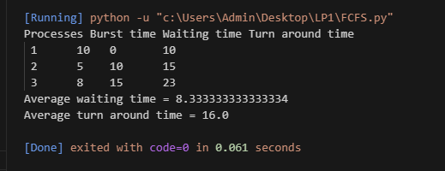

Name : Bhavika R. Parhate
Roll no : TB – 54

SJF (Preemptive):-
def main():
# Taking the number of processes
n = int(input("Enter number of processes: "))
# Matrix for storing Process ID, Burst Time, Waiting Time & Turnaround Time
A = [[0 for _ in range(4)] for _ in range(100)]
total, avg_wt, avg_tat = 0, 0, 0
print("Enter Burst Time:")
# User input for Burst Time and assigning Process ID
for i in range(n):
A[i][1] = int(input(f"P{i + 1}: ")) # Burst Time
A[i][0] = i + 1 # Process ID
# Sorting processes according to their Burst Time
for i in range(n):
index = i
for j in range(i + 1, n):
if A[j][1] < A[index][1]:
index = j

# Swap Burst Times
A[i][1], A[index][1] = A[index][1], A[i][1]
# Swap Process IDs
A[i][0], A[index][0] = A[index][0], A[i][0]
# Initialize waiting time for the first process
A[0][2] = 0
# Calculate waiting times
for i in range(1, n):
A[i][2] = sum(A[j][1] for j in range(i)) # Waiting time
total += A[i][2]
avg_wt = total / n
total = 0

# Calculation of Turnaround Time and printing the data
print("P\t BT\t WT\t TAT")
for i in range(n):
A[i][3] = A[i][1] + A[i][2] # Turnaround time
total += A[i][3]
print(f"P{A[i][0]}\t {A[i][1]}\t {A[i][2]}\t {A[i][3]}")
avg_tat = total / n
print(f"Average Waiting Time = {avg_wt}")
print(f"Average Turnaround Time = {avg_tat}")
if __name__ == "__main__":
main()

Output :-

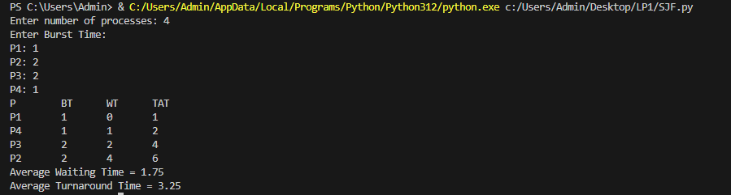

Name : Bhavika R. Parhate
Roll no : TB – 54

Priority (Non-Preemptive) :-
def main():
# Taking the number of processes
n = int(input("Enter the number of processes: "))
# Arrays to store process details
p = [0] * 10 # Process IDs
pp = [0] * 10 # Priorities
bt = [0] * 10 # Burst Times
w = [0] * 10 # Waiting Times
t = [0] * 10 # Turnaround Times
print("Enter the burst time and priority for each process:")
for i in range(n):
print(f"Process[{i + 1}]")
bt[i] = int(input("Burst Time: ")) # Input Burst Time
pp[i] = int(input("Priority: ")) # Input Priority
p[i] = i + 1 # Assigning Process ID

# Sorting processes based on priority (higher number indicates higher priority)
for i in range(n - 1):
for j in range(i + 1, n):
if pp[i] < pp[j]:
# Swap priorities and corresponding burst times and IDs
pp[i], pp[j] = pp[j], pp[i]
bt[i], bt[j] = bt[j], bt[i]
p[i], p[j] = p[j], p[i]

# Initialize waiting time and turnaround time
w[0] = 0
awt = 0
t[0] = bt[0]
atat = t[0]
# Calculate waiting and turnaround times
for i in range(1, n):
w[i] = t[i - 1] # Waiting time
awt += w[i]
t[i] = w[i] + bt[i] # Turnaround time
atat += t[i]

# Print the process details
print("Process \t Burst time \t Wait time \t TAT \t Priority ")
for i in range(n):
print(f"{p[i]}\t\t{bt[i]}\t\t{w[i]}\t\t{t[i]}\t\t{pp[i]}")
# Calculate and print average waiting time and turnaround time
awt /= n
atat /= n
print(f"Average Wait time: {awt}")
print(f"Average TAT: {atat}")
if __name__ == "__main__":
main()
Output :-
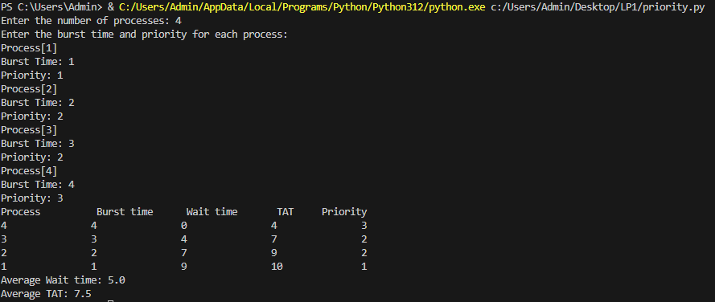
Name : Bhavika R. Parhate
Roll no : TB – 54
Round Robin (Preemptive):-
def findWaitingTime(processes, n, bt, wt, quantum):
rem_bt = [0] * n # Remaining burst times

# Copy the burst time into rem_bt[]
for i in range(n):
rem_bt[i] = bt[i]
t = 0 # Current time

while True:
done = True

for i in range(n):
if rem_bt[i] > 0: # There is a pending process
done = False # Mark as not done

if rem_bt[i] > quantum:
t += quantum
rem_bt[i] -= quantum
else:
t += rem_bt[i]
wt[i] = t - bt[i] # Waiting time
rem_bt[i] = 0 # Process finished
# If all processes are done
if done:
break
def findTurnAroundTime(processes, n, bt, wt, tat):
# Calculating turnaround time
for i in range(n):
tat[i] = bt[i] + wt[i] # TAT = BT + WT

def findavgTime(processes, n, bt, quantum):
wt = [0] * n # Waiting time
tat = [0] * n # Turnaround time
findWaitingTime(processes, n, bt, wt, quantum)
findTurnAroundTime(processes, n, bt, wt, tat)
# Display processes along with all details
print("Processes Burst Time Waiting Time Turn-Around Time")
total_wt = 0
total_tat = 0
for i in range(n):
total_wt += wt[i]
total_tat += tat[i]
print(f" {i + 1}\t\t {bt[i]}\t\t {wt[i]}\t\t {tat[i]}")
print("\nAverage waiting time = %.5f" % (total_wt / n))
print("Average turn around time = %.5f" % (total_tat / n))
# Driver code
if __name__ == "__main__":
# Process IDs
proc = [1, 2, 3]
n = 3
# Burst time of all processes
burst_time = [10, 5, 8]
# Time quantum
quantum = 2
findavgTime(proc, n, burst_time, quantum)

Output :-
